kadineberwise@yahoo.com

Phone: 718-555-5555

Grades K - 8

Resources
School Counseling Program
As School Counselor we are …

Students advocates and partners in student achievement first, last, and always.
Kadine Berwise
School Counselor
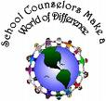

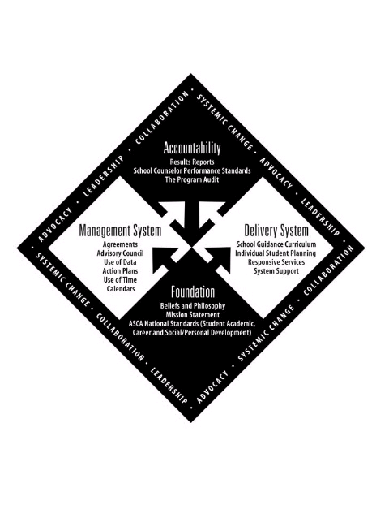

American Counseling Association
5999 Stevenson Avenue
Alexandria,Virginia 22304
Toll Free: 800-347-6647
Phone: 703-823-9800
Fax: 703-823-0252
www.counseling.org

American School
Counselor Association
1101 King Street, Suite 625
Alexandria, Virginia 22314
Toll Free: 800-306-4722
Phone: 703-683-2722
Fax: 703-683-1619 Fax
www.schoolcounselor.org

EdTrust
http://www.2.edtrust.org

Collegeboard
http://professionals.collegeboard.com

National Association for College Admission Counseling
www.nacanet.org/memberportal/default.htm

Who are School Counselors?
Professional school counselors, formerly referred to as “guidance counselors,” are professional educators who have a master’s degree or higher in school counseling (or the substantial equivalent), and are certified or licensed by the state in which they work.

Professional school counselors possess the qualifications and skills necessary to address the full array of students’ academic, personal, social, and career development needs.

Professional school counselors advocate for and care for students, and are important members of the educational team. They consult and collaborate with teachers, administrators and families to help all students be successful academically, vocationally and personally.

School Counseling Program

What Do School Counselors Do?
- Mental, emotional, social, developmental, and behavioral services to students and families
- Academic guidance and support services, including organizational, study and test-taking skills for students.
- Special education services, including serving as integral member of the student’s Individual Education Plan (IEP).

- Career awareness, exploration and planning services, including goal setting and decision making assistance for students.

- School crisis intervention and response services.

- Collaboration and coordination of more in-depth services needed through community agencies.

- Interpreting cognitive, aptitude and achievement tests.

- Analyzing grade-point averages in relationship to achievement.

- Collaborating with teachers to present proactive, prevention-based counseling curriculum lessons.

What Is ASCA?
The American School Counselor Association (ASCA) created The ASCA National Model: A Framework for School Counseling Programs. The ASCA National Model supports the school’s overall mission by promoting academic achievement, career planning and personal/ social development. It serves as a framework to guide states, districts and individual schools in designing, developing, implementing and evaluating a comprehensive, developmental and systematic school counseling program.

The ASCA National Model consists of four interrelated components: foundation, delivery system, management systems and accountability. The first component, foundation, dictates how the program is managed and delivered, which in turn, leads to the accountability of the program. The information gathered through the accountability process should refine and revise the foundation. Infused throughout the program are the qualities of leadership, advocacy and collaboration, which lead to systemic change.

